**C PROJECTS:**

**Ques1: MINI VOTING SYSTEM**

**Coding:**

#include<stdio.h>

int main()

{

int age;

printf("\n enter age");

scanf("%d",&age);

if(age>=18)

{

printf("you are eligible for vote");

}

int choice;

printf("press 1 for BJP\n press 2 for CONGRESS\n press 3 for BSP\n press 4 for AAP");

printf("enter choice");

scanf("%d",choice);

if(choice==1)

{

printf("\n***YOU HAVE VOTED FOR BJP***");

}

else if(choice==2)

{

printf("****YOU HAVE VOTED FOR CONGRESS***");

}

else if(choice==3)

{

printf("***YOU HAVE VOTED FOR BSP***");

}

else if (choice==4)

{

printf("***YOU HAVE VOTED FOR AAP***");

}

}

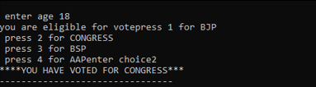

**Ques2: ELECTRICITY BILL**

**Coding:**

#include<stdio.h>

int main()

{

int units;

float total_bill;

printf("----------------------------\n-----------------------------");

printf("\n HPSl ");

printf("\n ELECTRICITY BILL ");

printf("\n------------------------------------");

printf("\n");

printf("consumer details ");

printf("\n--------------------------------------");

printf("\n\n");

printf("Nainshi lakharwal");

printf("\n\n.vill.&P.O kujabalh,,,,176090,,\nMandi");

printf("\n\nAElec Sub-Divn:5522\na/Cno. G-172-DSDE\ncon id:1000000258903\nIst No.:4000000766432\nTarif catg:IDS\nmeter No.:14567493\nSup voltage:0.40ku");

printf("\n\nBILL DETAILS");

printf("\n----------------------------------------");

printf("\n An electricity board chages the\following rates to domestic users\n to discourage large consumpt of \nenergy:");

printf("\n\n0 units to 50 units----------=Rs.2.5/unit");

printf("\n51 units to 100 units----------=Rs.3/unit");

printf("\n101 units to 200 units----------=Rs.3.5/unit");

printf("\n201 units to 300 units----------=Rs.4/unit");

printf("\n301 units to 400 units----------=Rs.4.5/unit");

printf("\n401 units to 500 units----------=Rs.4.75/unit");

printf("\n and more then 500 units--------=Rs.5/unit");

printf("\n-------------------------------------------");

printf(" enter the number of units:");

scanf("%d",&units);

if(units<=50)

{

float total_bill=units*2.5;

printf("total bill to be paid by you=Rs.%f",total_bill);

}

else if(units<=100)

{

float total_bill=units*3;

printf("total bill to be paid by you=Rs.%f,total_bill");

}

else if(units<=200)

{

float total_bill=units*3.5;

printf("total bill to be paid by you=Rs.%f",total_bill);

}

else if(units<=300)

{

float total_bill=units*4;

printf("total bill to be paid by you=Rs.%f",total_bill);

}

else if(units<=400)

{

float total_bill=units*4.5;

printf("total bill to be paid by you=Rs.%f",total_bill);

}

else if(units<=500)

{

float total_bill=units*4.75;

printf("total bill to be paid by you=Rs.%f",total_bill);

}

else

{

float total_bill=units*5;

printf("total bill to be paid by you=Rs.%f",total_bill);

}

}

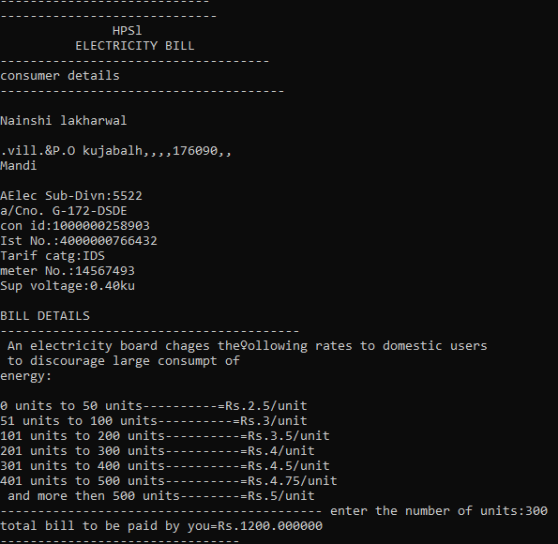

**Ques: 3 STUDENT RECORD MANAGEMENT SYSTEM**

**Coding:**

#include<stdio.h>

#include<conio.h>

int main()

{

char name[34];

int roll_no;

int registration_id;

printf("Enter Roll_no=");

scanf("%d",&roll_no);

printf("\n-----------------------");

if(roll_no==1)

{

printf("\nName of student=Nainshi");

printf("\nRoll_no of student=1");

printf("\nRegistration_id of student=786");

}

else if(roll_no==2)

{

printf("\nName of student=Vishal");

printf("\nRoll_no of student=2");

printf("\nRegistration_id of student=467");

}

else if(roll_no==3)

{

printf("\nName of student=Aarav");

printf("\nRoll_no of student=3");

printf("\nRegistration_id of student=0045");

}

else if(roll_no==4)

{

printf("\nName of student=Akash");

printf("\nRoll_no of student=4");

printf("\nRegistration_id of student=5465");

}

else if(roll_no==5)

{

printf("\nName of student=Kashish");

printf("\nRoll_no of student=5");

printf("\nRegistration_id of student=218");

}

else

{

printf("\nNo student found");

}

}

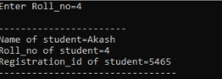

**C++ PROJECTS:**

**Ques1: BANKING MANAGEMENT SYSTEM**

**Coding:**

#include<iostream>

using namespace std;

class account

{

public:

char name[90];

int accountnumber;

int deposit;

char type;

void getdata()

{

cout<<"\n****enter the following details to create type****";

cout<<"\n***************************************************";

cout<<"\nenter the name of account holder";

cin>>name;

cout<<"\nenter the accountnumber";

cin>>accountnumber;

cout<<"\nenter the amount to be deposit";

cin>>deposit;

cout<<"\nenter the type of account";

cin>>type;

cout<<"\n**********Account is created***********";

cout<<"\n******************************************************";

cout<<"\n| Account holder is |"<<accountnumber;

cout<<"\n| Name of Account holder |"<<name;

cout<<"\n| Type of account |"<<type;

cout<<"\n| Deposit amount |"<<deposit;

cout<<"\n******************************************************";

}

};

int main()

{

account a;

a.getdata();

}

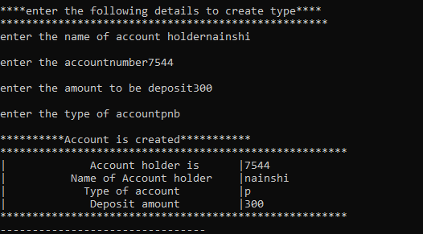

**Ques2: CAR RENTAL SYSTEM**

**Coding:**

#include<iostream>

using namespace std;

class rent

{

public:

string invoice_no;

char name[90];

char model;

int days;

int number;

int amount;

int advance;

void getdata()

{

cout<<"*****CAR RENT-CUSTOMER INVOICE*****"<<endl;

cout<<"///////////////////////////////////"<<endl;

cout<<"enter invoice_no----------------";

cin>>invoice_no;

cout<<"enter customer name-------------";

cin>>name;

cout<<"enter car model------------------";

cin>>model;

cout<<"enter no of days-----------------";

cin>>days;

cout<<"enter car no---------------------";

cin>>number;

cout<<"enter rental amount-----------------";

cin>>amount;

cout<<"enter advance------------------------";

cin>>advance;

cout<<"***************************************"<<endl;

cout<<"--------total rental amount is---------"<<amount<<endl;

cout<<"***************************************"<<endl;

}

};

int main()

{

rent r;

r.getdata();

}

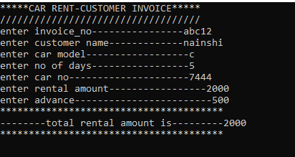

**Ques:3 HOTEL MANAGEMENT SYSTEM**

**Coding:**

#include<iostream>

using namespace std;

class hotel

{

public:

char hotel_name[90];

int available_room;

void getdata()

{

cout<<"*******HOTEL MANAGEMENT SYSTEM*********"<<endl;

cout<<"-----------------------------------------"<<endl;

cout<<"enter hotel_name";

cin>>hotel_name;

cout<<"enter available_room";

cin>>available_room;

int choice;

cout<<"enter choice";

cin>>choice;

if(choice==1)

{

cout<<"AC rooms are available"<<endl;

}

else

{

cout<<"NON AC room are available"<<endl;

}

}

};

class details:public hotel

{

public:

char name[90];

string address;

int booking_number;

int phone_number;

int payment_advance;

int from_date;

int to_date;

void getdata1()

{

cout<<"*****************************************"<<endl;

cout<<"******customer details*******"<<endl;

cout<<" enter the name";

cin>>name;

cout<<" enter the address";

cin>>address;

cout<<"enter the booking_number";

cin>>booking_number;

cout<<"enter the phone_number";

cin>>phone_number;

cout<<"enter the payment in advance";

cin>>payment_advance;

cout<<"from_date";

cin>>from_date;

cout<<"to_date";

cin>>to_date;

}

};

class room:public details

{

public:

int room_no;

void getdata2()

{

cout<<"*********************************************"<<endl;

cout<<"enter room_no";

cin>>room_no;

cout<<"**************************************************"<<endl;

cout<<"YOU HAVE BOOKED ROOM NUMBER 5 WITH AC SUCCESSFULLY"<<endl;

cout<<"**************************************************";

}

};

int main()

{

hotel h;

h.getdata();

details d;

d.getdata1();

room r;

r.getdata2();

}

}

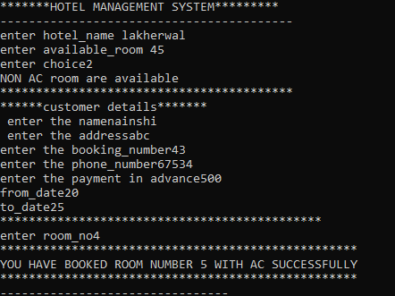

**Ques4: BILLING SYSTEM**

**Coding:**

#include<iostream>

using namespace std;

class billing

{

public:

int item1;

int item2;

int item3;

int item4;

int item5;

int item6;

int item7;

int total;

void getdata()

{

cout<<"**************************************************"<<endl;

cout<<"***********BILLING MANAGEMENT SYSTEM**************"<<endl;

cout<<"**************************************************"<<endl;

cout<<"******************CASH RECEIPT********************"<<endl;

cout<<"**************CONFECTIONARY SHOP******************"<<endl;

cout<<"Address is 1265 mall road shimla "<<endl;

cout<<"Date is 20/08/2023 "<<endl;

cout<<"Cashier name is Nainshi "<<endl;

cout<<"--------------------------------------------------"<<endl;

cout<<"Number of items=7"<<endl;

cout<<"Name of item with price"<<endl;

cout<<"price of 1item(lays)=";

cin>>item1;

cout<<"price of 1item(kurkure)=";

cin>>item2;

cout<<"price of 1item(chocolate)=";

cin>>item3;

cout<<"price of 1item(biscuit)=";

cin>>item4;

cout<<"price of 1item(candies)=";

cin>>item5;

cout<<"price of 1item(cold drinks)=";

cin>>item6;

cout<<"price of 1item(juice)=";

cin>>item7;

cout<<"total"<<item1+item2+item3+item4+item5+item6+item7<<endl;

cin>>total;

cout<<"-------------------------------------------------"<<endl;

cout<<"*******************THANK YOU*********************"<<endl;

cout<<"-------------------------------------------------"<<endl;

}

};

int main()

{

billing b;

b.getdata();

}

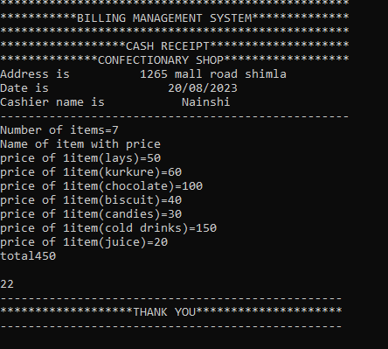

**Ques5: SCHOOL MANAGEMENT SYSTEM**

**Coding:**

#include<iostream>

using namespace std;

class school

{

public:

char name[80];

string address;

int staff;

int strength;

int rooms;

char games[100];

void data()

{

cout<<"...***SCHOOL MANAGEMENT SYSTEM***..."<<endl;

cout<<"------------------------------------"<<endl;

cout<<"........Details about school........"<<endl;

cout<<"------------------------------------"<<endl;

cout<<"Enter name of school=";

cin>>name;

cout<<"Enter address=";

cin>>address;

cout<<"Enter total staff of school=";

cin>>staff;

cout<<"Enter total strength of students=";

cin>>strength;

cout<<"Enter classrooms in school=";

cin>>rooms;

cout<<"Enter games=";

cin>>games;

}

};

class staff:public school

{

public:

int choice;

void data1()

{

cout<<"------------------------------------"<<endl;

cout<<"........Details about staff........"<<endl;

cout<<"------------------------------------"<<endl;

cout<<"Enter choice=";

cin>>choice;

if(choice==1)

{

cout<<"Name of teacher=Nainshi lakherwal"<<endl;

cout<<"Qualification of teacher=BCA,MCA"<<endl;

cout<<"Salary of teacher=20000"<<endl;

cout<<"Subjects teacher teach=ASP.NET,VB.net"<<endl;

cout<<"Experience of teacher=6 years"<<endl;

cout<<" ................. "<<endl;

}

if(choice==2)

{

cout<<"Name of teacher=Renuka"<<endl;

cout<<"Qualification of teacher=BA,MA"<<endl;

cout<<"Salary of teacher=22000"<<endl;

cout<<"Subjects teacher teach=Hindi,English"<<endl;

cout<<"Experience of teacher=5 years"<<endl;

cout<<" ................. "<<endl;

}

if(choice==3)

{

cout<<"Name of teacher=Dinesh Rana"<<endl;

cout<<"Qualification of teacher=PGDCAC"<<endl;

cout<<"Salary of teacher=15000"<<endl;

cout<<"Subjects teacher teach=DBMS"<<endl;

cout<<"Experience of teacher=4 years"<<endl;

cout<<" ................. "<<endl;

}

if(choice==4)

{

cout<<"Name of teacher=Anita Devi"<<endl;

cout<<"Qualification of teacher=BSC.,MSC."<<endl;

cout<<"Salary of teacher=10000"<<endl;

cout<<"Subjects teacher teach=Chemistry"<<endl;

cout<<"Experience of teacher=4 years"<<endl;

cout<<" ................. "<<endl;

}

if(choice==5)

{

cout<<"Name of teacher=Rohit Thakur"<<endl;

cout<<"Qualification of teacher=BCom,MCom"<<endl;

cout<<"Salary of teacher=16000"<<endl;

cout<<"Subjects teacher teach=Account"<<endl;

cout<<"Experience of teacher=10 years"<<endl;

cout<<" ................. "<<endl;

}

}

};

class student:public staff

{

public:

int choice;

void data2()

{

cout<<"------------------------------------"<<endl;

cout<<"........Details about student........"<<endl;

cout<<"------------------------------------"<<endl;

cout<<"Enter choice=";

cin>>choice;

if(choice==1)

{

cout<<"Class=1st"<<endl;

cout<<"Number of sections=Section A,Section B"<<endl;

cout<<"Number of students in Section A=40";

cout<<"Number of students in Section B=30"<<endl;

cout<<"Total number of students=70"<<endl;

cout<<"Monthly fees of per student=3000"<<endl;

cout<<"Incharge of the class=Nainshi"<<endl;

cout<<"...This is the record of class 1st..."<<endl;

}

if(choice==2)

{

cout<<"Class=2nd"<<endl;

cout<<"Number of sections=Section A,Section B"<<endl;

cout<<"Number of students in Section A=50";

cout<<"Number of students in Section B=40"<<endl;

cout<<"Total number of students=90"<<endl;

cout<<"Monthly fees of per student=3000"<<endl;

cout<<"Incharge of the class=Rajeev Kumar"<<endl;

cout<<"...This is the record of class 2nd..."<<endl;

}

if(choice==3)

{

cout<<"Class=3rd"<<endl;

cout<<"Number of sections=Section A,Section B"<<endl;

cout<<"Number of students in Section A=30";

cout<<"Number of students in Section B=29"<<endl;

cout<<"Total number of students=50"<<endl;

cout<<"Monthly fees of per student=2000"<<endl;

cout<<"Incharge of the class=Nainshi"<<endl;

cout<<"...This is the record of class 3rd..."<<endl;

}

if(choice==4)

{

cout<<"Class=4th"<<endl;

cout<<"Number of sections=Section A,Section B"<<endl;

cout<<"Number of students in Section A=25";

cout<<"Number of students in Section B=25"<<endl;

cout<<"Total number of students=50"<<endl;

cout<<"Monthly fees of per student=2000"<<endl;

cout<<"Incharge of the class=Nainshi"<<endl;

cout<<"...This is the record of class 4th..."<<endl;

}

if(choice==5)

{

cout<<"Class=5th"<<endl;

cout<<"Number of sections=Section A,Section B"<<endl;

cout<<"Number of students in Section A=30";

cout<<"Number of students in Section B=30"<<endl;

cout<<"Total number of students=60"<<endl;

cout<<"Monthly fees of per student=2000"<<endl;

cout<<"Incharge of the class=Nainshi"<<endl;

cout<<"...This is the record of class 5th..."<<endl;

}

}

};

int main()

{

school s;

s.data();

staff f;

f.data1();

student t;

t.data2();

}

